Merrill’s Packaging Inc.,
1529 Rollins Rd., Burlingame
650 259-5959

CAREER OPPORTUNITIES
APPRENTICESHIP PROGRAMS,
MECHANICS AND MACHINE OPERATORS NEEDED!

We offer competitive wages and benefits for
Career orientated individuals with a desire to actually make something!
To join our team, please call to schedule an interview.
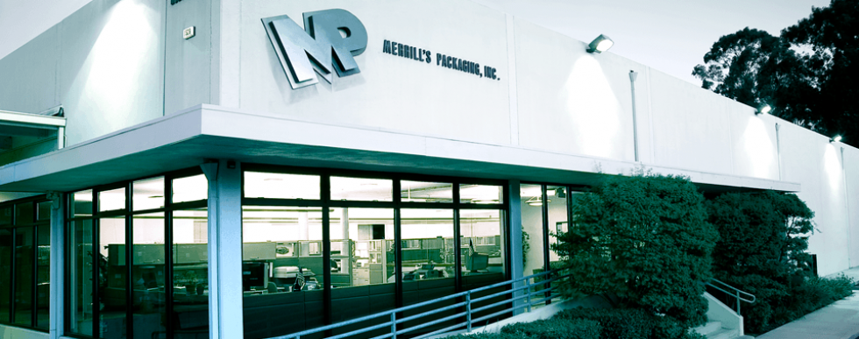

MECHANIC NEEDED: Merrill's Packaging/1529 Rollins Rd., Burlingame/ 650 259-5959 | MECHANIC NEEDED: Merrill's Packaging/1529 Rollins Rd., Burlingame/ 650 259-5959 | MECHANIC NEEDED: Merrill's Packaging/1529 Rollins Rd., Burlingame/ 650 259-5959 | MECHANIC NEEDED: Merrill's Packaging/1529 Rollins Rd., Burlingame/ 650 259-5959 | MECHANIC NEEDED: Merrill's Packaging/1529 Rollins Rd., Burlingame/ 650 259-5959 | MECHANIC NEEDED: Merrill's Packaging/1529 Rollins Rd., Burlingame/ 650 259-5959 | MECHANIC NEEDED: Merrill's Packaging/1529 Rollins Rd., Burlingame/ 650 259-5959 | MECHANIC NEEDED: Merrill's Packaging/1529 Rollins Rd., Burlingame/ 650 259-5959

