We are a $40MM job shop/contract manufacturer established in 1964 that serves the ruthless and uncompromising high-tech Bay Area customer by providing everything they want when they want it. Manufacturing parts in one of the most expensive locations in the country for some of the most demanding customers in existence is not easy. Boring widget shop we are not. We need good, dedicated, engaged team members to keep the dream alive. Apply if this sounds like you.

Job Openings:

TIG Welders Quality Inspectors

CNC Setup Machinist Deburr/ Grinders

Assemblers Drivers

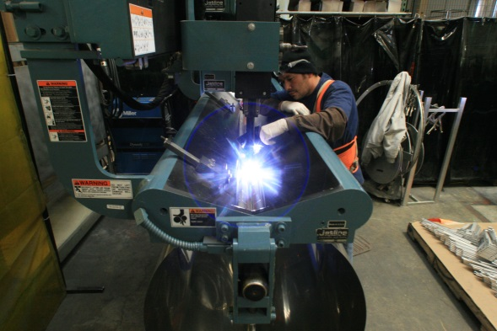
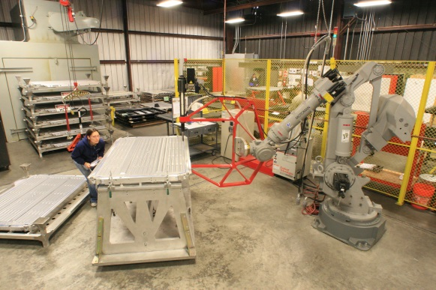
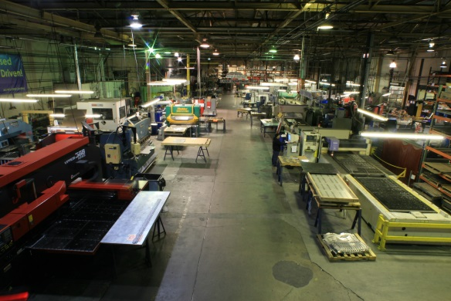

Benefits include:
-401K
-Medical/Dental
-Vacation and Holiday pay

Please apply by emailing your resume to jobs@inlandmetal.com

Inland Metal Technologies, Inc. 3245 Depot Road, Hayward, CA 94545 (510) 785-8555

www.inlandmetal.com

