Help wanted
En Pointe Precision is precision machine shop looking for a part-time Jr. Machinist to join our team! We have two 5 axis mills and a 3 axis ultrasonic mill. The successful candidate is able to thrive in a fast paced/tight deadline environment.

Position Responsibilities:
- Set up the manual and CNC mills for the operation
- Use all general machining tools and equipment, manual or CNC machines.
- Verifying conformance of finished work piece to specifications using standard measuring tools.
- Thoroughly inspect first article run.
- Maintain tools and equipment in good order so that the machine shop is ready to support the production needs all time.
- A track record of being consistent with attendance and prompt arrival at work.
- Document procedures and processes.
- Performs other duties and/or specific projects as assigned.

Requirements:
- HS Diploma or equivalent is preferred
- 1-3 years of machine shop experience or completion of apprentice program
- Must be able to read and understand industry and standard drawings.
- Ability to use caliper, micrometer, and indicators etc. measurement tools to ensure the dimensions of the machined part meet the drawing specifications.
- Knowledge of basic machine language, including M-codes and G-codes is a plus.
- Knowledge of manual machining operations like milling machine and lathe,
- Ability to read and interpret documents, safety rules, work instructions, and standard operating procedures (SOP)
- Setup and operate vertical milling machines
- CNC programming with MasterCam is a plus.
- Knowledge of 5 axis vertical mills is a plus
- Ability to lift and/or move by pushing/pulling up to 50 lbs.

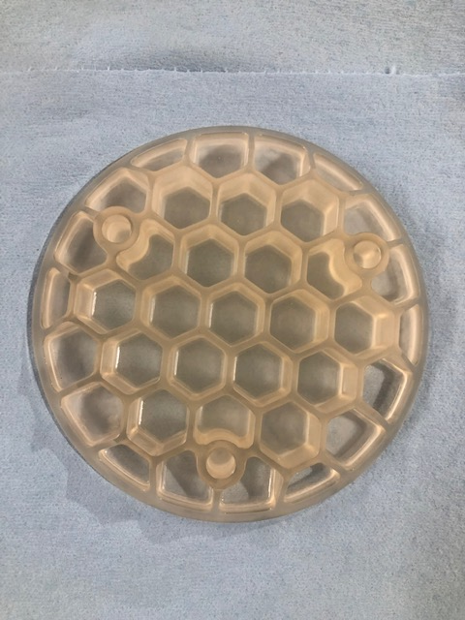
Light-weighted Zerodur Mirror machined on OptiPro ultra sonic mill

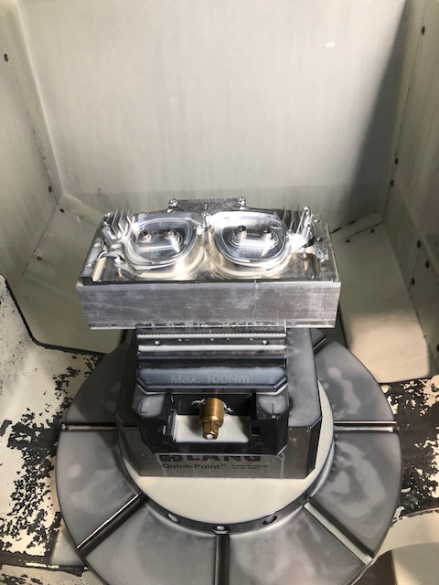
Frame in process on Kitamura 5 axis mill

