cid:image004.jpg@01CD22F6.6E6DA0F0

**PARTNERS WITH**

C:\Users\mavidano\Desktop\BenchmarkLogo.gif

**LOOKING FOR A CAREER OPPORTUNITY?**

Apply at: **3478 Buskirk Ave Suite 110 Pleasant Hill, CA 94523**

[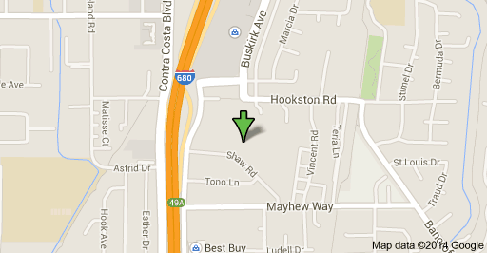](https://maps.google.com/maps?bav=on.2,or.r_qf.&bvm=bv.75097201,d.aWw,pv.xjs.s.en_US.FvBciXsFzrw.O&biw=847&bih=491&dpr=1&um=1&ie=UTF-8&fb=1&gl=us&q=3478+Buskirk+Ave,+Pleasant+Hill,+CA+94523&sa=X&ei=X78ZVMvLEMmSyATsnIDgDw&ved=0CB0Q8gEwAA)

Phone 925-685-5700, Fax 925-685-5892

We have multiple positions available in a fast paced manufacturing/ machine shop environment. Day and swing shifts, Overtime available, competitive pay, temp to perm opportunities.

Below are some of the positions we need talent for immediately:

|  |  |  |  |
| --- | --- | --- | --- |
| **Deburr Operator** | **Assembler** | **Buyer/ Planner** | **Machinist** |
|  |  |  |  |
| **Service Engineer** | **CMM Programmer** | **CNC Programmer** | **Data Entry** |
|  |  |  |  |
| **Material Handler** | **Shipping/ Receiving** | **Inspector** | **Technician** |
|  |  |  |  |
|  |  |  |  |
|  |  |  |  |
|  |  |  |  |
|  |  |  |  |