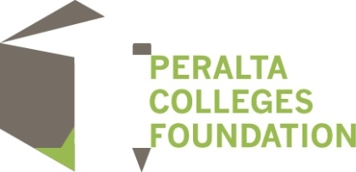

Scholarships are being offered for the Spring Semester of 2015

Applications open the first day of classes January 20, 2015

Application deadline:
March 9, 2015 @ 11:59pm

To apply go to www.peraltafoundation.org and click on:

For a complete list of the scholarships, the applications for scholarships and grants, and information on the California Dream Act please visit our website.
It is recommended that all applicants for this scholarship complete the Free Application for Financial Aid (FAFSA) and any other required forms through the Financial Aid Office to provide the selection committee with the applicant’s financial needs assessment. However, under the California Dream Act (AB 130) students attending a Peralta college who are exempt from paying nonresident tuition under AB 540 are eligible to receive scholarships funded by private donations and administered through the Peralta Colleges Foundation. See the Master Scholarship Application for other acceptable ways to demonstrate financial need.

