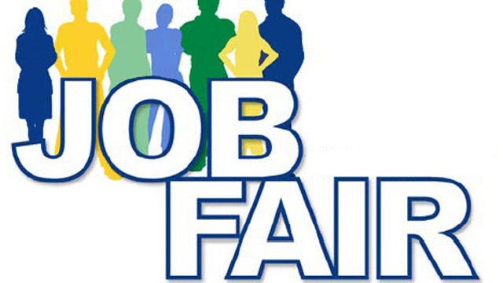

Thursday, October 29, 2015

11:30am to 1:30pm
Laney Community College Quad
**Dress For Success **Bring Your Resumes
**Come Prepared to Speak and Meet Employers

Meet Companies Hiring For Positions In:

- Business
- Retail
- Building Trades
- Cosmetology
- Early Childhood Ed.
- Life Sciences
- Administration
- Customer Service
- Construction
- Electrical Building Trades
- HVAC
- Culinary Arts
- Electronics
- Information Systems
- Machining
- Wood Working
- Culinary Arts

The Laney College Fall Job Fair is sponsored by the Laney College Career Center, Tower Building - Room 201
For more information, please contact Raya Zion at rzion@peralta.edu

