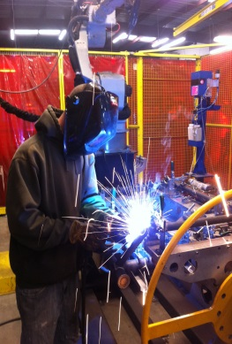 | 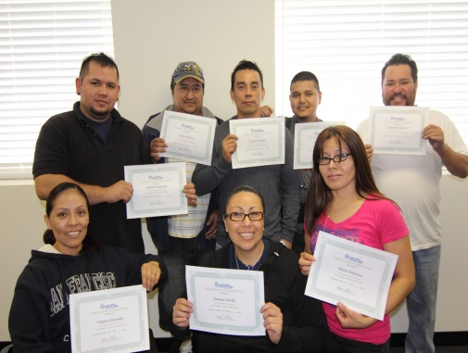 | 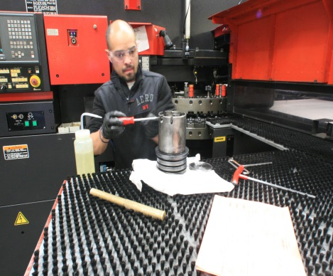 | 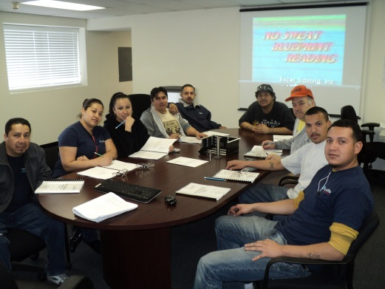

NOW HIRING! Multiple Openings for Entry Level Welders (MIG and Robotic)

For more than 45 years, Inland Metal Technologies has been a leading provider of precision sheet metal fabrications, enclosures, weldments and assemblies. We are one of the top growing privately held manufacturing companies in the Bay Area. Our facility is located in Hayward, CA, with approximately 300 employees.
We have a number of full-time positions for MIG and Robotic Welders having up to 1 year experience in welding or recent completion of a welder certification (MIG welding) or minimally 6 months of welder training. The openings are for Swing Shift (2:30pm-11:00pm). With this schedule there may be flexibility to work around your class schedule.
Excellent Benefits including:
-401K
-Industry leading pay levels
-Medical/Dental/Aflac
-Vacation and Holiday pay
-Internal training programs/certifications
POSITION REQUIRES:
- Up to 1 year experience in MIG welding or robotic welding, OR recent completion of welder certification (MIG welding); minimum requirement is at least 6 months formal training in welding or equivalent
- Experience grinding and finishing a plus
- Able to read blueprints a plus
- Experience using basic hand tools

To apply, please email your resume to: jobs@inlandmetal.com

Inland Metal Technologies, Inc., 3245 Depot Road, Hayward, CA 94545, (510) 785-8555
http://www.inlandmetal.com

