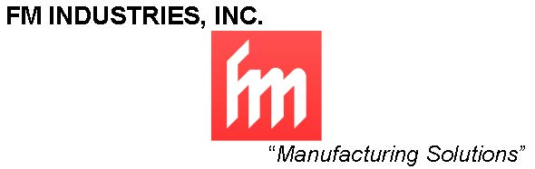

Come join the team at FM Industries!

We are hosting an Open House, hiring for the following positions:
CNC Machinists/Deburrers/Finishers/Assembly Techs

When: Saturday, July 23, 2016
Time: 8:00am to 11:00am
Interviews will be conducted onsite
Where: 221 Warren Ave Fremont, CA 94539

*Applications will be available at the Reception Desk

