3245 Depot Road

Hayward, CA 94545

WELDER, MIG/TIG, PRECISION (entry level & experienced)

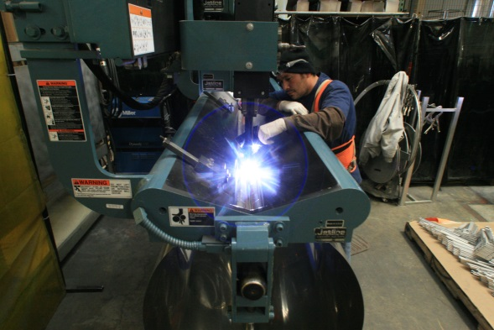
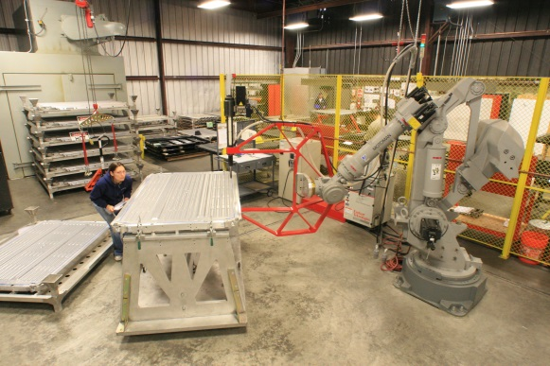
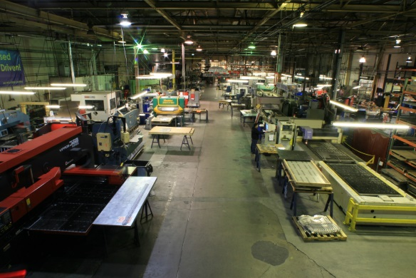
A leader in precision sheet metal/frame fabrication and an equal opportunity employer has several open positions for Robotic Welders, qualified MIG and also experienced TIG Sheet metal Welders.

Excellent Benefits including:
-401K
-Industry leading pay levels
-Medical/Dental
-Aflac
-Vacation and Holiday pay
POSITION REQUIREMENTS:
- Applicant must be able to fully capable of safe and efficient operation of welding equipment, saws, grinders, sanders, and hand tools.
- Applicant must be able to setup welding machine correctly for the process of welding light gage aluminum and steel and weld using MIG or TIG process to produce full penetration, quality, and attractive welds without excessive heat or blow out in both vertical and horizontal applications in accordance with customer requirements or company procedures.
- Applicant must be able to read welding requirement from customer drawings or blueprints and pass pre-employment welding test including a blueprint and welding symbol reading test
- Applicant must be able to understand and execute standard welding procedures and processes
- Applicant must be able to inspect one’s own work and use precision measuring instruments such as calipers, go/no-go gages,
- Applicant must be able to use or create simple fixture jigs
- Applicant must have own hand tools
- Applicant must be able to complete all data entry and paperwork fully and accurately
Please apply by emailing your resume to jobs@inlandmetal.com

