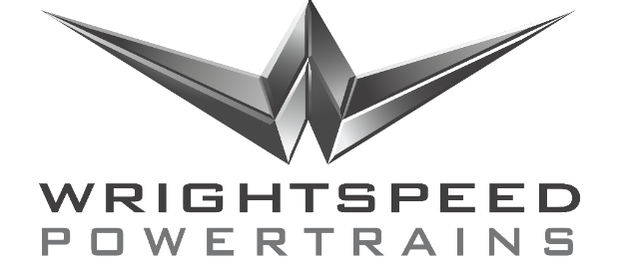

Position: CNC Machinist

Desired start date: ASAP
Employment status: Full Time (Temp-to-Hire available)
Wage / salary range:

Summary
The CNC Machinist will support prototype and pilot small-quantity production of components for the Wrightspeed range-extended powertrain.

Roles and Responsibilities
Create and modify production and prototype parts for use by Wrightspeed in commercial electric vehicle powertrains with range-extending turbine generators. Parts may be used within or in support of batteries, gearbox, turbine, or as support, protection, or retention of other items. Responsibilities include but are not limited to the following:
- Computer Aided Manufacturing (CAM) programming;
- Fixture design and fabrication;
- Using Computer Numerical Control (CNC) machines to cut, shape, or otherwise fabricate parts from steel and other metals or materials;
- Using other industrial equipment, including saws, brakes, drills, etc., as provided in the Wrightspeed facility;
- Understanding, interpreting, and implementing requested modifications to items;
- Proposing alternate methods, means, or materials, as appropriate;
- Exercising reasonable judgement and appropriate care in the use of industrial equipment and materials in a multi-purpose workspace.

Skills and Experience Required
- 3+ years of experience as a machinist
- Prior experience with fixturing, set-up, and machining of complex parts with challenging features.
- Communication skills to interface with design engineers, integration engineers, and manufacturing engineers.
- Integrity, energy, sense of urgency and attention to detail behaviors are expected.
- Prior experience with MasterCAM.
- Prior experience programming Haas controllers.
- Prior experience working in start-up environment and/or heavy truck industry.

Hiring Manager

Signature
Date
Title | Vlad Kalika
Company | Director, Development Engineering

