For more than 45 years, Inland Metal Technologies has been a leading provider of quality precision sheet metal fabrications, enclosures, weldments and assemblies. Our facility is located in Hayward, CA with approximately 360 employees. We are in the Bay Area’s top 100 fastest growing, privately held companies.

Job Openings:

Project Manager (Engineering) Robotic Weld Operator

TIG Welder Material Handler

Entry Level Welder Brake Operator

Deburr/ Grinders Jr. Process Planner

Shop Helper Mazak Laser Operator

Production Admin Assistant Mitsubishi Laser Operator

Powder Coating Paint Specialist QA Inspector

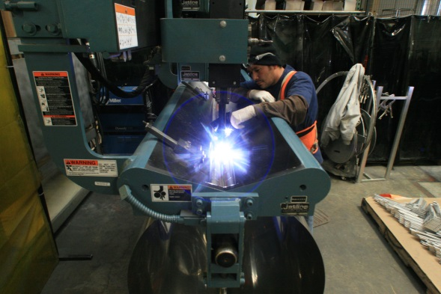
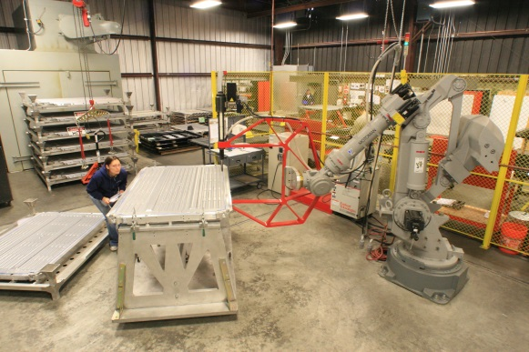
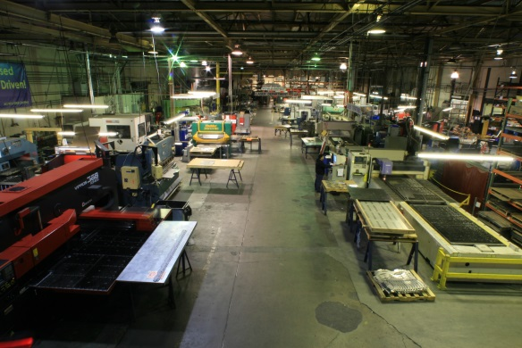
Excellent Benefits including:
-401K
-Industry leading pay levels
-Medical/Dental
-Aflac
-Vacation and Holiday pay

Please apply by emailing your resume to jobs@inlandmetal.com

Inland Metal Technologies, Inc. 3245 Depot Road, Hayward, CA 94545 (510) 785-8555

www.inlandmetal.com

