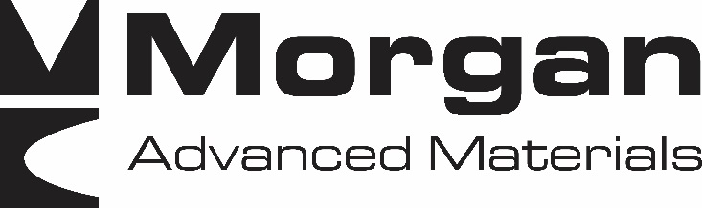

Morgan Advanced Materials is a global engineering company with over 8,800 employees across 50 countries. We are a world-leader in advanced materials science and engineering of ceramics, carbon, and composites. Morgan operates in a series of well-defined markets where our applications expertise offers our customers a valuable differentiator, engineering high-specification materials, components and sub-assembly parts that solve their challenging technical problems. Our markets include healthcare, petrochemicals, transport, electronics, energy, security, and industrial.
The following job positions are currently open at our Hayward, CA site. All of the positions are full-time, offer day or night shifts, and are in a union environment.

1. CNC Operator (4 positions available)
Job Skills:
- Plans machining by studying work orders, blueprints, engineering plans, materials, specifications, drawings, locations of surfaces, and machining parameters; interpreting geometric dimensions and tolerances (GD&T).
- Plans stock inventory by checking stock to determine amount available; anticipating needed stock; placing and expediting orders for stock; verifying receipt of stock.
- Programs mills and lathes by entering instructions, including zero and reference points; setting tool registers, offsets, compensation, and conditional switches; calculating requirements, including basic math, geometry, and trigonometry; proving part programs. – Program MasterCamm
- Loads feed mechanism by lifting stock into position.
- Verifies settings by measuring positions, first-run part, and sample workpieces; adhering to international standards.

2. ISO Press Operator
Job Skills:
- Set up and operate ISO press machine tools and equipment.
- Calculate shrink factors and select powders to match up with tooling.
- Select and set up tooling to match powders.
- Inspect produced product using typical measuring equipment.

3. Blanchard Operator
Job Skills:
- Follow all Safety and environmental rules and regulations.
- Required to wear appropriate personal protective equipment at all times.
- May set up and/or operate one or more of the following machine(s), using vises, fixtures, chucks, etc., concurrently in assigned area under limited supervision: CNC Lathe, CNC Mill, Hone, Band saw, Surface Grinders, Chamfer Grinder, Radius Grinder, Swing-arm Drill Press, various Mechanical Presses, Universal Grinders, Manual Lathes & Mills, ISO Press, Lap Machine, Dual Lap Machine, Polish Machine, Tumbler Machine, Sandblaster, Pressure Caster, Blanchard, Cleaning Line, Manual Drill Press, , Centerless Grinder, ID Grinder, Microblast Machine, and Slicing Machine.
- Performs complex set-ups on a variety of equipment using an advanced level of tooling.
- Ensures that all set-ups are properly executed on manual equipment
- May design and build complex tooling and fixturing as necessary to support machining requirements.
- Must be proficient in Geometric Dimensioning and Tolerencing (GD&T).
- May perform basic machine adjustments, if necessary (off-sets, dressing wheels, setting tapers), on manual machines.
- May read and interpret technical drawings to determine machine set-up and production methods.
- May visually or mechanically inspect parts for defects (cracks, chips, dimension, surface finish, etc.) as part of in-process inspection; records results and notifies lead/supervisor of deviation as appropriate. May use one of more of the following for measuring and inspection: various types of Tape.
- Measures, Steel rulers, O.D., I.D. and depth Micrometers, Calipers, Profilometers, Refractometers, Height Gauge, Optical Comparator, and CMM (Coordinate Measuring Machine).
- Understands and meets or exceeds quality standards; seeks to minimize reject rate.
- Follows approved electronic work instructions; follows established department procedures, which may be found in electronic or paper form. Incumbent must be capable of finding and referencing work instructions when asked.
- May be required to perform some simple machine preventative maintenance functions, i.e. changing coolants, lubricants, filters, etc. May update preventative maintenance schedules as needed.
- Keeps machines, work area and factory clean; notifies supervisor or maintenance when machine abnormalities occur.
- May be required to interpret basic control charts and simple capability studies within Statistical Process Control (SPC).
- May enter data into Statistical Process Control (SPC) software and is alert for abnormal variation and out of tolerance conditions.
- Is the recognized expert and may be sought out to perform leadership duties as necessary.
- Must serve as a resource to others in the resolution of complex technical problems.
- Possess the ability to use the computer system for basic departmental functions.
- Have the ability to train other employees as needed.

Preferred Skills:
- Proficiency with all CNC control systems within area of responsibility.

Required experience:
- Grinding: 3 years

How to Apply:
Please submit your resume to hr.hayward@morganplc.com. For questions or further information, please call 510-491-1115. Thank you for your consideration of Morgan Advanced Materials. We look forward to hearing from you. www.morganadvancedmaterials.com

