cid:image004.jpg@01CD22F6.6E6DA0F0

**PARTNERS WITH**

C:\Users\mavidano\Desktop\BenchmarkLogo.gif

**On-site Job Fair!**

**Wednesday, July 19th from 11am-2pm**

**Meet at our office:**

**4041 Pike Lane, Building 1, Concord, CA 94520**

[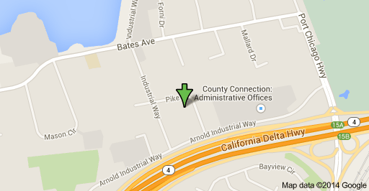](https://www.google.com/maps/place/4041+Pike+Ln,+Concord,+CA+94520/@38.010711,-122.031826,15z/data=!4m2!3m1!1s0x808567aebd39320f:0xbfaf27ae5da3c27?sa=X&ei=8gNlVK2zLcuTyATWz4HoCw&ved=0CB0Q8gEwAA)

**Phone 925-363-1113, Fax 925-363-1198 or email:** [**sInthanoune@thessg.com**](mailto:sInthanoune@thessg.com)

We have multiple positions available in a fast pace manufacturing/ machine shop environment. Day and swing shifts, overtime available, competitive pay with temp to perm opportunities.

**Immediate Openings for:**

* **Machinist - Finisher – Welder**
* **Machine Operator – Precision Inspector**
* **CNC Programmer – Production Team Lead**
* **Shipping/ Receiving – Material Handler**
* **Facilities Maintenance Technician**