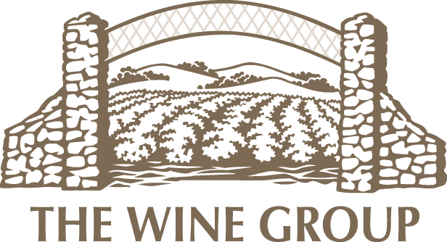

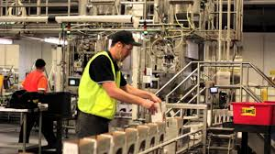
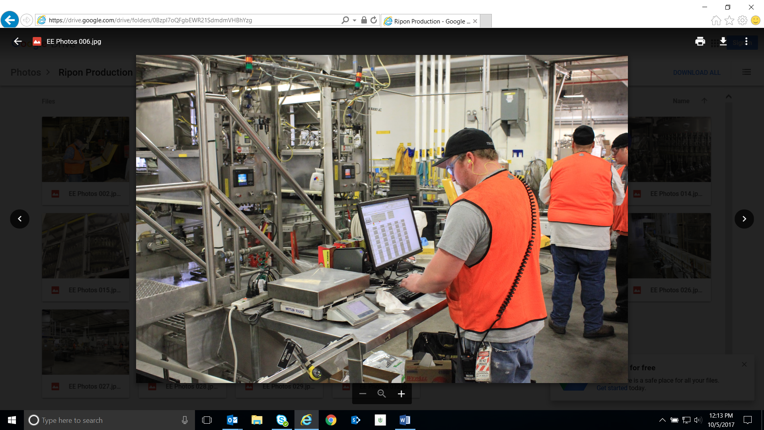
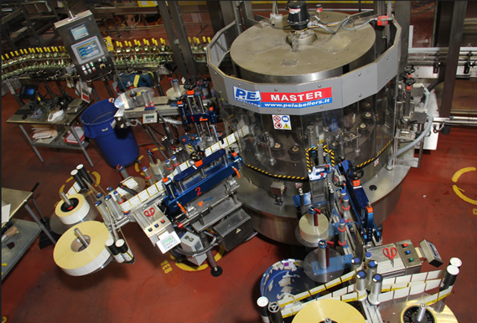
Technicians Wanted – Livermore & Ripon areas
- Do you like problem solving?
- Do you enjoy working on complex & challenging tasks?
- Are you curious & like learning different responsibilities?
- Do you want to work in the wine Industry?
If you answered YES!
…And you are self-motivated, energetic individual that wants to grow with a top leading company in the wine industry.
CHECK US OUT & APPLY TODAY!!! - www.thewinegroup.com/careers
ABOUT THE POSITION
We are currently seeking candidates with experience or a desire to learn & advance in Manufacturing, Industrial, and Electrical Engineering.

This position is responsible for the operation and maintenance of bottling lines.
Expect to:
- program, troubleshoot, repair and maintain plant equipment
- Perform PM’s on all manufacturing equipment
- Process operations consist of delivery of wine, operating and adjusting high speed filling/packaging equipment
- Execute all Sanitation, GMP and QC practices

Following is a PLUS:
- PLC Repair
- Advanced leadership skills
- Analytical, Detail oriented, can multi-task in a fast paced environment
ABOUT US
The Wine Group has a proud history dating back to the early 1900’s and has grown to the country’s third largest producer of wine by volume. With 14 locations across California, New York, and Australia, we thrive with exceptional people, strong values and well-known brands such as Franzia, Cupcake, Concannon, Benziger and Imagery.

