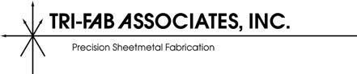

AVAILABLE POSITIONS

CNC Lathe Programmer & Operator
CNC Mill Operator
CNC Mill Programmer
CNC Machine Operator
QC Inspector
Account Manager/Sales Rep
Press Brake Operator
Deburrers
Welders (TIG)
Hardware Assembly
Junior Estimator
Shipping Clerk
Customer Service Rep

For additional information, visit www.Trifab.com or
Submit resume to HR@trifab.com

