is hiring!
Ready for the next step on your career?
VOLT Workforce Solutions is connecting talented applicants with great opportunities at top companies all over East Bay and Nationwide. Submitting your application profile to VOLT means you will be considered for current openings as well as other positions that you’re qualified for as they become available.
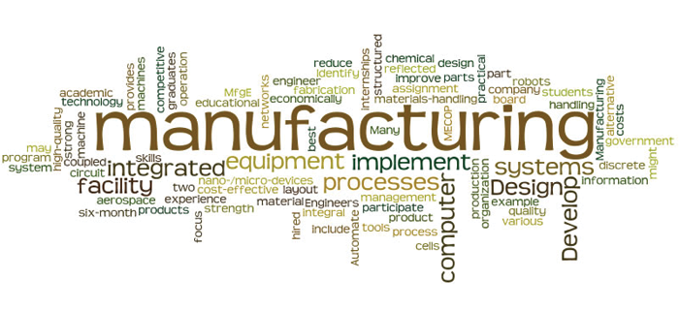
VOLT is hiring a number of Forklift Drivers / Material Handlers / Production Associates & Assemblers to work for VOLT at a Top Energy-Efficient Manufacturing Company in Fremont California. We are seeking candidates with open availability to work for a duration of 6 months with full time hours. These positions can be involved in any part of the Manufacturing Process, including component and vehicle assembly. Hourly Pay is $19.00 to $20.90 (according to shift)
*Qualifications:
- Must be 18 years old or over
- GED / High School Diploma or higher
- Valid Drivers’ License / California ID
- Must pass a background check going back 7 years
- No experience necessary

*There will be an assessment test for each candidate to pass prior to an interview.
*Please don’t forget to bring your most recent copy of resume

For any questions please email - Ncampbell@volt.com
Direct Line - 510 789 - 2265

