Subject: Varian’s Palo Alto Factory is Hiring! Come to Tour Day on March 2, 2019!
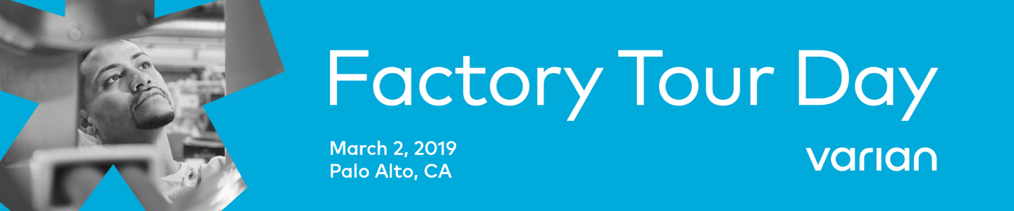
#TogetherWeWin

Imagine a career where you can do meaningful work that improves the lives of millions of people around the world and possibly someone you love. One in which you can help provide hope in the fight against cancer.

Hi! This is the recruiting team at Varian, and you’re invited to join us March 2 in Palo Alto for our Factory Tour Day and Open House. You’ll learn about Varian’s vision and mission, and how we work as a team to develop and build the technologies that help fight cancer.

Every day, we at Varian imagine a world without fear of cancer. We’re the world’s leading manufacturer of medical devices and software for treating and managing cancer. We innovate new technologies for treating cancer and for connecting clinical teams to advance patient outcomes. Through ingenuity, we inspire new victories and empower people in the fight against cancer. We are Varian.
We’re looking for skilled, passionate people to join our manufacturing team in Palo Alto, California, and help build the machines that improve the lives of patients all over the world. Their fight is our fight. Together, we win.
When you join Varian, you become part of a global network of more than 7,000 innovative and inspired minds working together to create the technologies and build the machines that help save lives and provide hope in the fight against cancer.
Click here to learn more, explore manufacturing careers opportunities, and sign up for a tour at our Factory Tour Day and Open House on March 2, 2019.
If you’re looking for a place where you can do meaningful work with great people and grow your career, consider joining the Varian team. Looking forward to seeing you on March 2 at Factory Tour Day!
- The Varian Talent Team

#TogetherWeWin #VarianTourDay

Varian
3100 Hansen Way
Palo Alto, CA 94304

