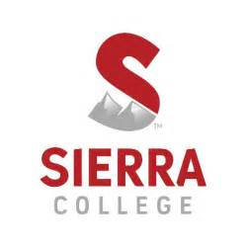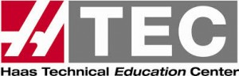

Northern California HTEC Conference
October 7, 2017

ALL Activities will be held in the ‘H’ building

8:00 – 8:30 am Registration, Networking
8:30 – 9:00 Welcomes & Attendees Introductions
9:00 – 9:30 Keynote – Montez King, NIMS – The National View of Manufacturing
9:30 – 10:00 Vendors Introductions and the services / products they provide
10:00 – 10:50 Education Panel – “What’s happening in the pipeline?”
Break-Out Sessions
Track 1 Track 2
11:00 – 11:35 Fusion 360 CAD, room H-5 NIMS in our area – room H-4
11:35 – 12:15 Fusion 360 CAM, room H-4 Completing the Design Cycle – Zeiss - room H-4
Integrating Coordinate Measuring Technology
12:15 – 1:00 Lunch – BBQ, provided by Selway, Machine Tool Co
mpany
1:00 – 1:20 Presentation – Kathy Looman, Gene HAAS Foundation

Track 1 Track 2
1:25 – 2:05 Part set-up, room H-3 Waterjet 1.0, room H-8
2:10 – 2:45 Both tracks – Making a Part, room H-3
3:00 Wrap-up of the Day & raffle drawing

5100 Sierra College Boulevard * Rocklin, California 95677

